Tanner Wale

## **What Is Utility Software? Understanding Its Types, Functions, and Why It's Crucial for System Optimization**

## **What Is Utility Software?**

What is utility software? Utility software is in the App Store on your devices. Including the Android Play Store, Windows Microsoft Store, and the iPhone App Store. You can also find other utility software tools on websites. Verify that the website is legitimate before downloading anything from the website. Utility software helps devices by supporting them in a multitude of ways.

Utility software does this by helping devices maintain, manage, and optimize performance. By using these tools correctly for devices one can see and feel the differences before and after.

This is because of the wide range of resources utility software provides. If the device is experiencing slow speeds opening or closing applications. Slow bootups, utility software can find out reasons why. So you can manage the situation better and prolong the life of the device.

You can plan for future disasters so that you're always prepared for the worst. Making backups and restoring data from those backups if needed. It is crucial to consider security for organizational devices. Like monitoring networks from network protocol analyzers such as Wireshark. This views and audits traffic in your network. Also, consider using network utilities to provide information about a device, to conclude whether an attack is still occurring. Conclude whether an attack has been stopped by the antivirus software by scanning the device again. The types and functions of utility software help with all these aspects, and more.

## **Understanding Its Types, Functions, and Why It's Crucial for System Optimization**

## **Antivirus Software**

Antivirus software helps the security of your device. It is a must to protect you from viruses, malware, and phishing scams, that are forever evolving. Antivirus software can also help against unauthorized access to your devices by blocking malware attacks. According to (Rosencrance, 2023), antivirus software can scan files, system memory, and folders for suspicious patterns and for known malware signatures. Examples include Bitdefender antivirus, Norton 360 antivirus, and Avast (Le, 2025).

This is done by executing tasks or accessing files in real time, where the antivirus software will check the file for malicious signatures and suspicious patterns. Antivirus software can quarantine the malware on your device. This quarantines the malicious attack from the rest of your device. As a spread of a malicious attack such as malware, can make the device nonfunctional. The antivirus software can help your device block and clean files of malicious signatures or suspicious patterns detected. Then scan for any more signs of a possible attack. Letting the user know when the device is safe to operate again.

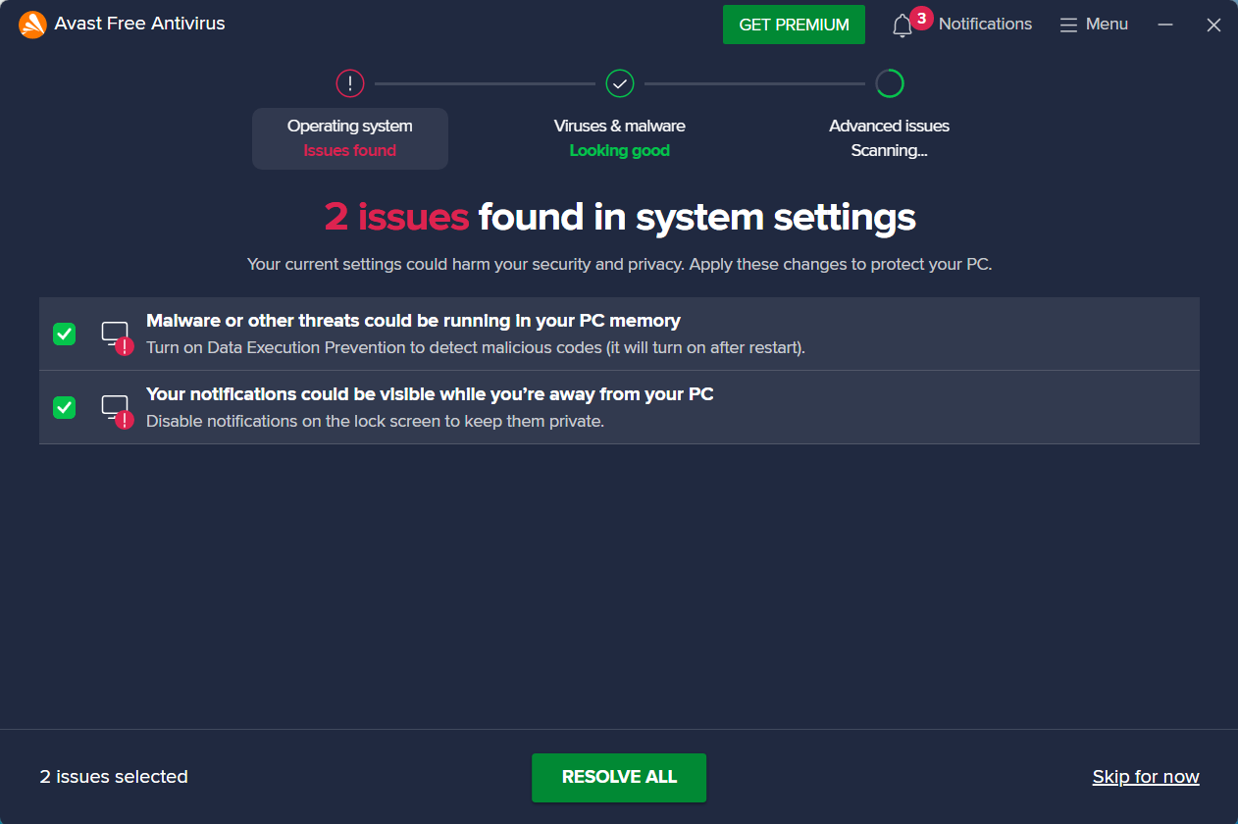

Alt text: Scanning for potential malware using Avast Free Software, 2 issues found on the operating system.

Another added benefit of having antivirus software is that you can also run automated scheduled scans. Scanning of your device can be done when you are not using it, to make better efficiency. To make the antivirus software most effective. Always look out for updates to antivirus software on your device. The latest malicious attack definitions are updated to detect and find the newest attacks. There is internet and email protection from antivirus software as well. Malicious websites are spotted with the help of antivirus software by using signature-based detection, Heuristic-based detection, signature-based detection, and more (Rosencrance, 2023). Also, antivirus helps defend against phishing emails. This type of attack is where the attacker pretends to be someone you trust. A trusted company or important individual. To trick into giving important individual information away. Attackers can use this to sell it on the dark web to make money or plan for another attack. Help from antivirus software is needed in this area, as this is the most common attack on the internet. The antivirus software will use the same techniques used for detecting malicious websites to block malicious email attachments. Universal Serial Bus (USB) is a common way to attack a device. This could be installed on the USB by accidentally downloading malware, or the attack could be intentional. Whatever the case may be, antivirus software can scan the USB or other external storage devices on the device. This will stop a malware or virus attack, installed on an external storage device. It will also stop malware from spreading from device to device. Leading to a high cost of remediating the issue.

## **Disk Cleanup**

Disk cleanup is a system maintenance type for utility software. It's common to use it to make more space on your devices. Scanning your hard drive or USB to get rid of junk files. Creating more space for important documents on your devices.

The user gets to select which files to remove from the system. For example, files in the recycling bin, temporary files, cached files, or system files in the disk cleaner are some of the options. Utility software will remove and show you how much space is taken up before and after deletion. By deleting these files, you can see your system improve quicker processing power, more efficient boot times, and overall system performance.

Due to constant maintenance on your device's hard drive or USB, you can create a healthier system. That reduces clutter and redundant files, leading to a longer life of the hard drive or USB. You can do more of your work, without having to manually waste time. By finding the files in your hard drive or USB to delete.

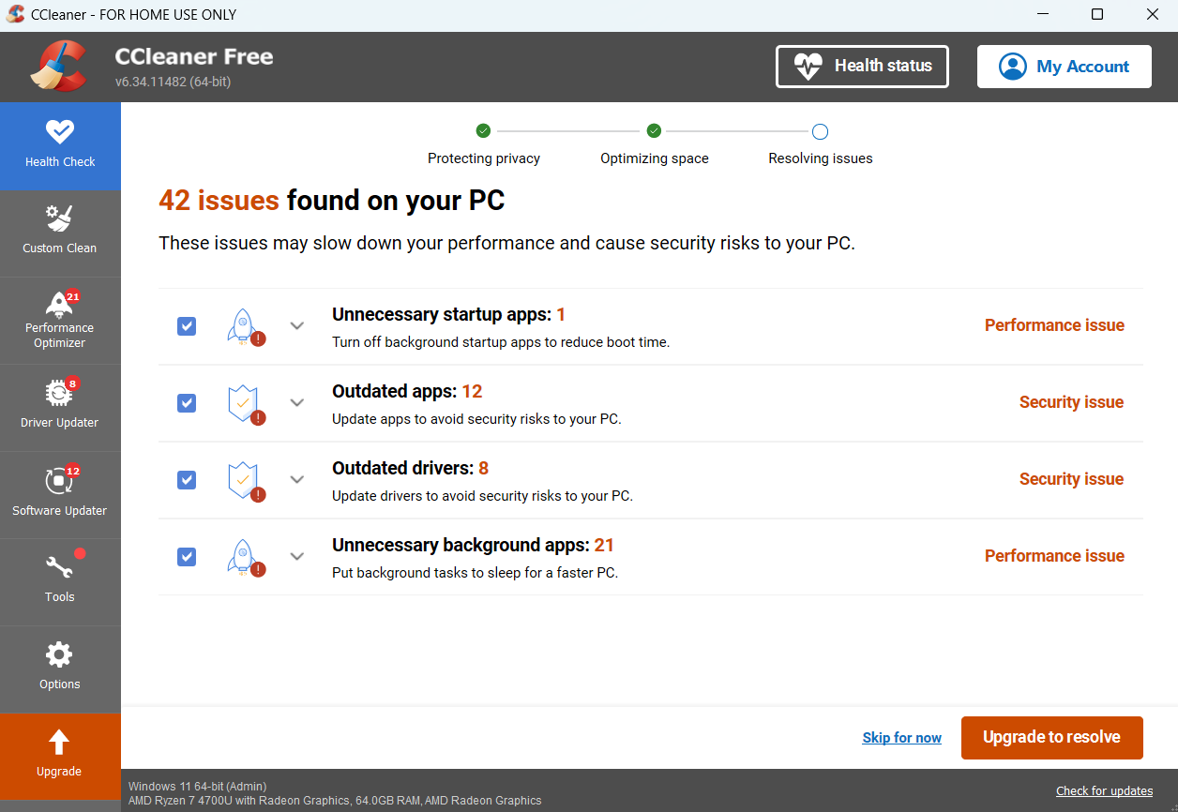

Alt text: CCleaner being used to clean junk files, 42 issues found on PC.

The files on your device are a security risk if not properly protected with access control privileges. CCleaner is a disk utility software tool that will let the user know the security issues with files. As well as the software applications that are outdated on the device. Allowing optimization for the device to improve the battery life cycle. Making boot up times faster, and helping with device performance overall.

## **Backup and Recovery**

Backup and recovery software is a data management tool. Providing backups for security disasters or incident responses. These functions allow for backup to accidental deletion of files, folders, applications, and complete operating systems.

Allowing for three different types of data backups such as incremental, full, and differential. Incremental backups only backup changes made since the last backup. Incremental backups are great because they do not take up as much storage space as full backups. Full backups allow you to copy your whole system as a backup restore point. However, the downfall of this is how long the copy of all applications, files, and data will take to complete. The available storage space it will take up is much more than incremental or differential backups. Differential backups provide changes made since the last full backup was used. You can recover from more than just accidental deletion of data files, folders, and applications. Such as malware attacks, software issues, and hardware failures.

Organizations and enterprises use backups for recovery to mitigate catastrophic failures to their businesses. Avoiding deletion of customers' Personal Identifiable Information (PII) by accessing backups and making a quick recovery. Some enterprises and organizations use automated backup and recovery processes to handle data tasks. So, failure is less likely to occur from human error. This also allows employees to focus on data protection or other tasks related to company data.

Data protection is another added benefit of using backups and recovery utility software. Encryption of data, unchangeable data, and no redundant backups to data, are offered by backup and recovery utility software. Examples of backup and recovery utility software include Clonezilla, Cobian Backup, and FreeFileSync. Also, free option with OneDrive found in the Settings, under Accounts on Windows, for backing up your files and folders.

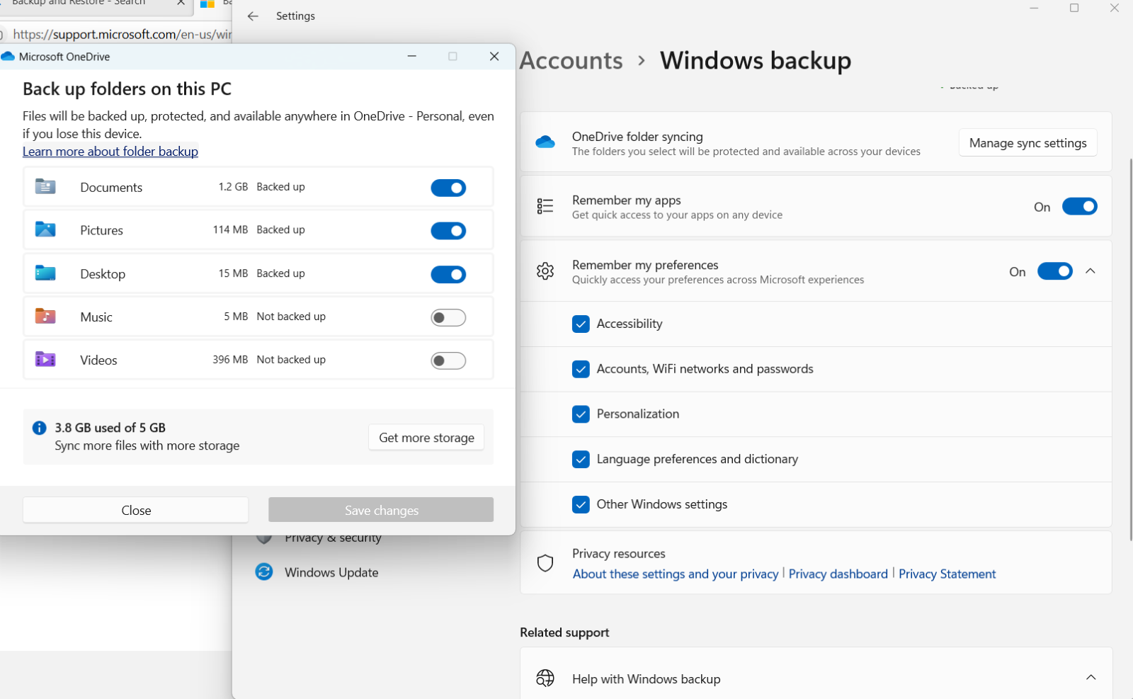

Alt text: Backing up files and folders on Windows backup software on PC.

## **File Management**

File management is a type of data management in utility software. Functions of file management are access control permissions to files. As well as creation, organization, and properties of files and folders. Copying and deleting files is another function of file management. Encryption of files and folders for security, such as needing certain permissions to access the files or folders.

File management will help in efficiency by sharing files and folders with your work. Instead of having to remake the same file and folders for all employees in your company. You can share it with everyone who has privileged access in your company. Organization with folders is another benefit to file management. As well as improving speeds and efficiency, by removing the clutter of files. File explorer is one an example of file management utility software.

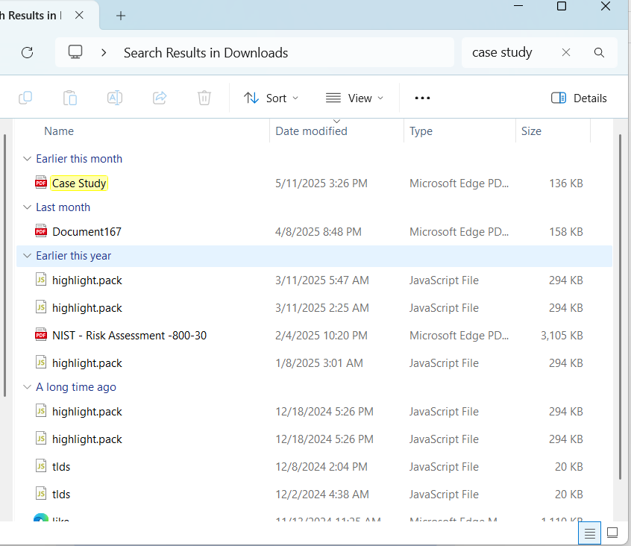

Alt text: File explorer search bar being used to find Case Study file.

Finding your files and folders through the search engine in File Explorer is an example of efficiency. As it makes it easier and faster to access data. By typing in case study all lower case or all letter uppercased will not make a difference. Making it more convenient to users.

## **System Monitoring**

System monitoring is a security tool that is mainly used for reporting issues with a device or network. System monitoring functions as a tool for optimization. Giving information to make smart and informed decisions from monitoring resources. Such as the Central Processing Unit (CPU), Random Access Memory (RAM), or Hard Disk Drive (HDD) and network usage. These resources can show signs of an issue that could be fixed through optimization. Cores application is an example of utility software that can monitor the hardware of your device.

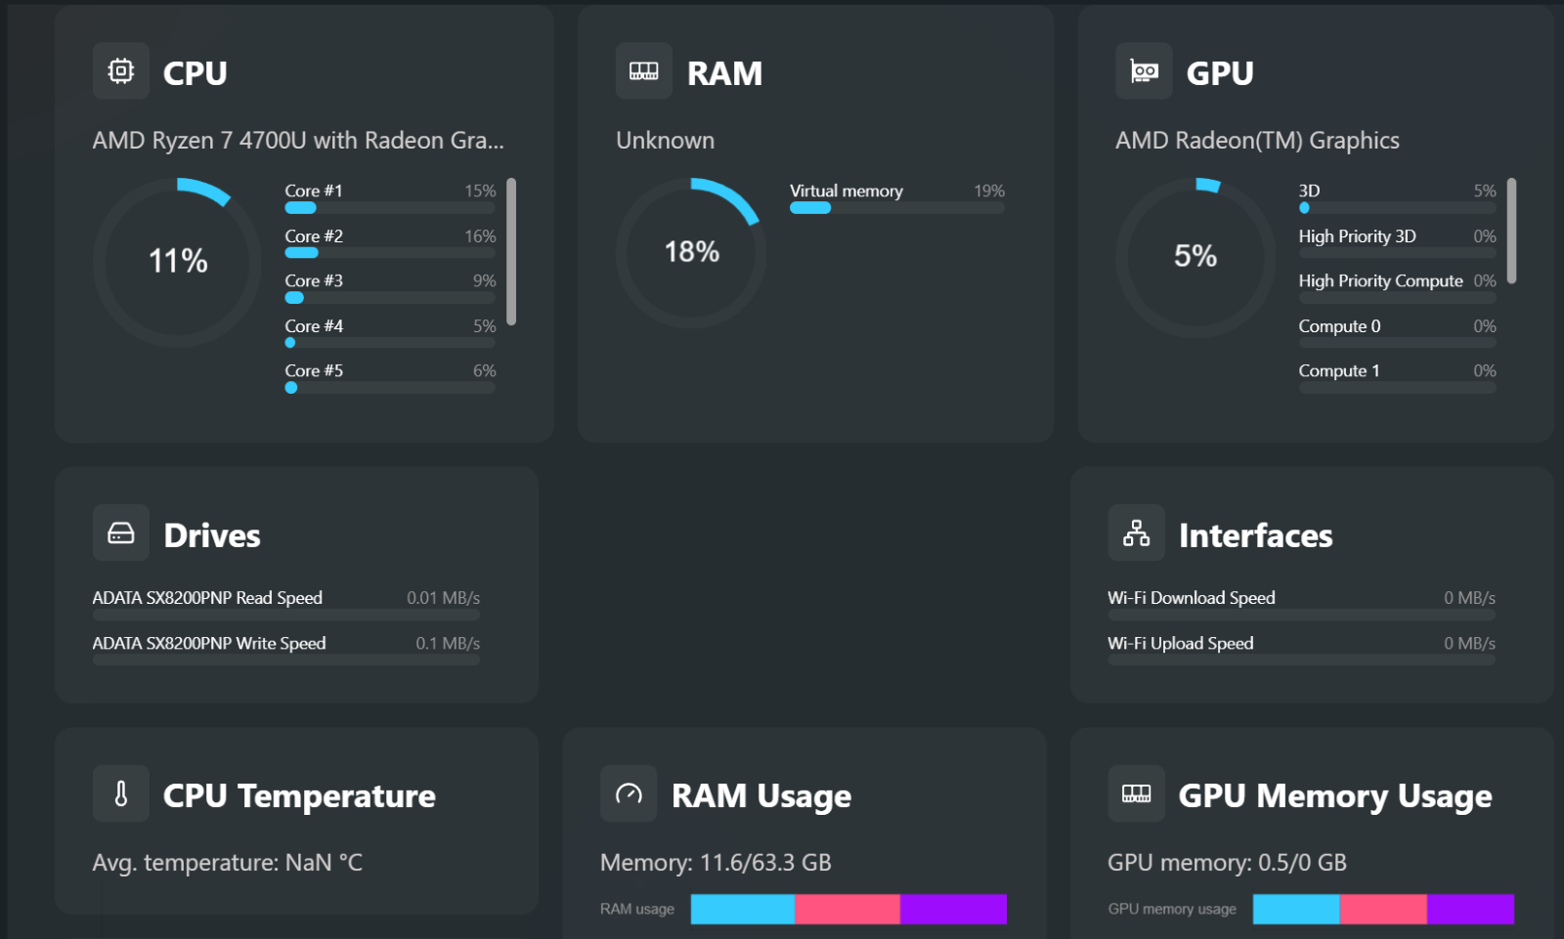

Alt text: System monitoring software showing resource utilization of CPU, RAM, and GPU.

Security system monitoring can be the first step in a defensive response. Generating alerts throughout a network for signs of an attack can help security respond faster to potential threats. Organizations like Amazon use systems monitoring for resource utilization and the cost of using that resource in real-time. This can help a company effectively plan for current use and future use.

By monitoring historical data to see areas of improvement in resources. Using this, the company can invest heavily in the busiest times of the year, to get more return on investment. Another use is for logging a track record of user interactions with resources and access privileges. To prove guilty of noncompliance and audit access controls if needed. System maintenance is helped by monitoring software to spot issues with devices' resource utilization.

## **System Optimization**

System optimization improves the performance of a device and is a vital part of utility software. If you have ever used power-saving mode on your devices, you have used system optimization. This makes the battery last longer, without needing to charge it within its normal battery life cycle. This is due to lower resource utilization than normal. If you have ever used your computer's bootup settings in Task Manager. To set which applications start when booting up, you have optimized your system. To be able to boot up faster (if selecting less software to boot up) than it normally does.

Another example is having outdated drivers for a printer, graphical card, or Network Interface Card (NIC). These all require drivers for the computer to be able to properly use these resources. By having outdated drivers, you might notice latency on your devices. Issues connecting to the internet or issues with printing tasks to your printer. Also, worse graphics than normal, due to the outdated driver.

By updating the drivers these issues can all be fixed. This is once again optimization being used, to more efficiently run resources to their maximum effectiveness on devices. CCleaner that was mentioned earlier, helps with disk cleaning utility but also optimization. CCleaner has a Performance Optimizer section that can scan for what could possibly be slowing down your device. Then, CCleaner can turn them off until used again. This will help utilize only what the user is using. So, the CPU does not get ruined or damaged by overuse. Helping to give a longer life cycle to the resources of the device as well.

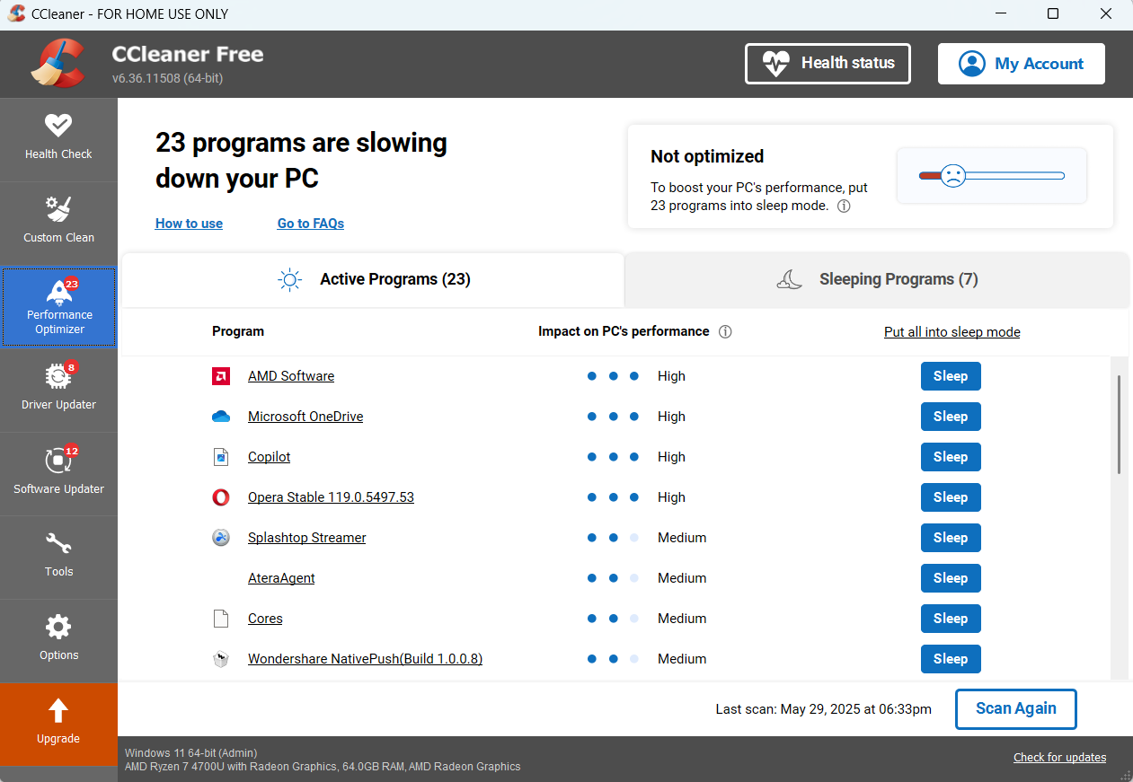

Alt text: CCleaner being used for system optimization, showing 23 programs slowing down PC.

## **Debugging Software**

Debugging software functions as performance, security, and system maintenance tools. Debugging software is a diagnostic tool software developers use. Open-source programming environments like Visual Studio, software developers use to write their programs. This tool diagnoses the problem and can help point out the errors so that the proper changes can be made. Without this tool, a programmer would have to look through hundreds or thousands of lines of code. Looking to fix their software program, because one simple mistake can make the program not work.

Debugger software can even give options for corrections to fix the problem. The debugger tool saves time and efficiency in a programmer's working projects, making it a no-brainer tool to have. The main use of debugging software is for programming purposes. As developers need these tools to do their job fast and efficiently.

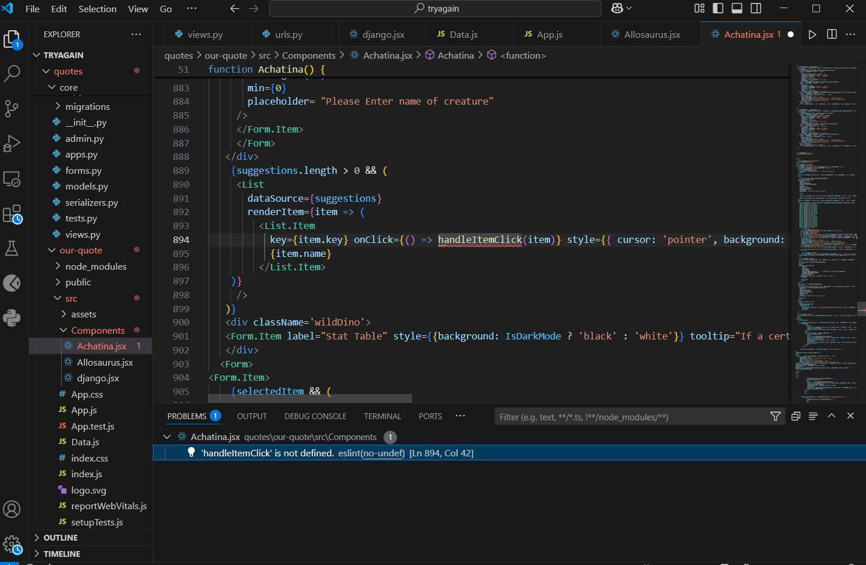

Alt text: Debugging software showing cause of error report and line error is found on.

As you can see from the picture, the debugger spotted an issue within the thousand lines of code. Showing an error with a variable not being defined to the programmer. This provides significant help, along with showing what file the issue is in. Also, with lines (Ln 894, Col 42) of where the error has occurred.

While debuggers can point out issues to programmers. Cutting their time in half to come up with solutions to their problems. This software can also help devices find issues and potential fixes. Debuggers have helped with hardware issues by identifying what caused the crash of the device. Software issues have also been helped by the debugging tool. Along with troubleshooting other technical problems, such as outdated legacy systems.

Outdated legacy systems are devices that are no longer supported by their manufacturers. This creates security issues for the device. As it will not be kept up-to-date with the latest known attacks. Knowing how to detect and defend against them. One also has to be aware that having an outdated system may lead to incompatible software. This is where the device is too old to use the newest version of the software application. This is because the device cannot support it with its current hardware. By rolling back versions of updates using optimization of an application. A user can find what best helps their device overcome compatibility issues with the application. Letting the user still be able to use that application on the outdated device. Examples of these outdated legacy systems are Windows XP, Windows 7, and Windows 8.

## **Registry Cleaners**

Registry cleaners function as data management and system maintenance tools. Registry cleaners are helpful for users by removing redundancy in the device's folders. The software the user downloads to their device will make less for the device's storage space. If the user decides to delete the application, the files can still be left behind on the devices. Deletion of the application does not fully delete all the files associated with the application. This leads to a decrease in storage capacity over time. If the user is constantly downloading applications, but not clearing all data files associated with those applications.

Registry cleaners come in by helping trace back the file's origin of an application folder. If nothing is found, it will automatically delete the file. So that the user does not have to manually find all of the files. To delete, after deleting the application as well. By using this process, software applications and operating system updates will no longer have outdated versions of the device. Helping security and improvements to the devices' load times, among other noticeable qualities like fewer software application errors.

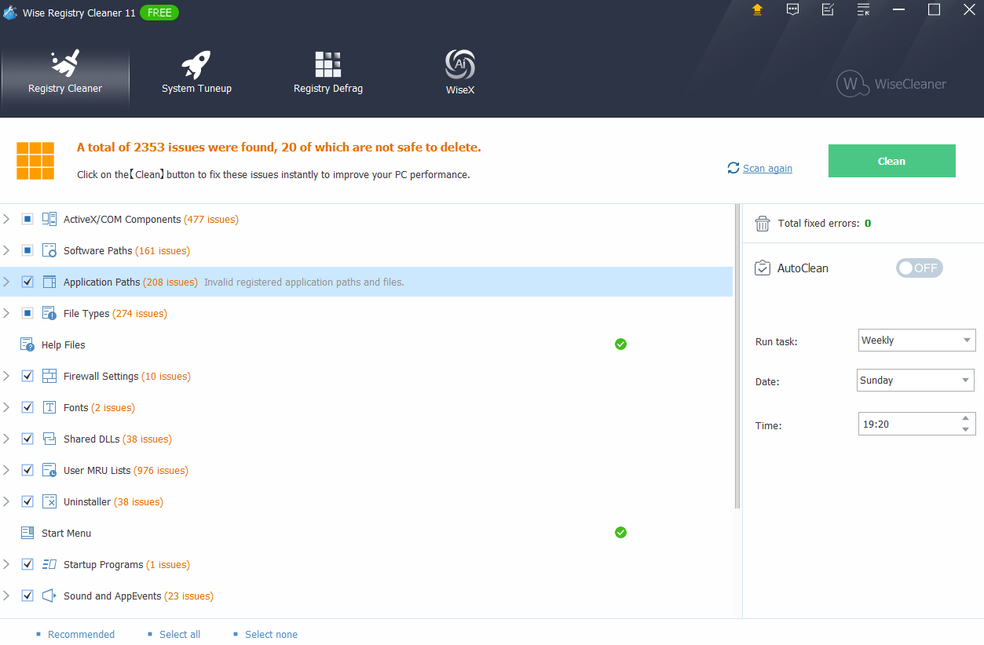

Alt text: Registry cleaner showing 2353 issues are found, 20 of which are not safe to delete.

## **Network Utilities**

Network utilities function as a network management tool and are used for security purposes. This is commonly used by network administrators to troubleshoot connectivity issues in their dedicated network. Using the Command Line Interface (CLI) program to type in their commands. Commands such as ping IP address to test other devices. You should see four packets sent and received successfully to conclude it is connected. To fully see and test connection to a network like Local Area Networks (LANs) or Wide Area Networks (WANs). Network administrators use commands within the CLI tool such as Tracert. To help learn the route of packets from one destination to another. This command gives network admins the information they need to identify latency in packets transmitted.

In an organization, computers may be connected to the organization's private servers to be secure. Using a command such as IPCONFIG /all. To help give network admins the IP address of the Domain Name Server (DNS) server the computer is connected to. Also, this gives information about the computer's default gateway, subnet address, and the computer's (IP) address. To make sure it is in the correct range of IP addresses. To connect to and be able to communicate with other devices on the network.

The other command a network admin uses in their daily jobs to secure networks for their organization is Netstats. This command is very useful because it gives information about routing tables. Also, active connections throughout a network, and provides relevant information for troubleshooting connectivity issues. Nmap is another command that helps with security. By scanning a network for vulnerabilities like open ports and is used in security auditing.

Another network utility tool network admins use to secure and monitor their networks is Wireshark. Which is a network protocol analyzer tool. This will provide users with information about their network packets. Such as what protocols are being used for packets, to secure their networks properly. There are more examples of network utility commands. More tools as well to use for security and getting information to troubleshoot issues within a network. The images below show IPCONFIG /all being used to show DNS, DHCP server configuration, and physical address of the device.

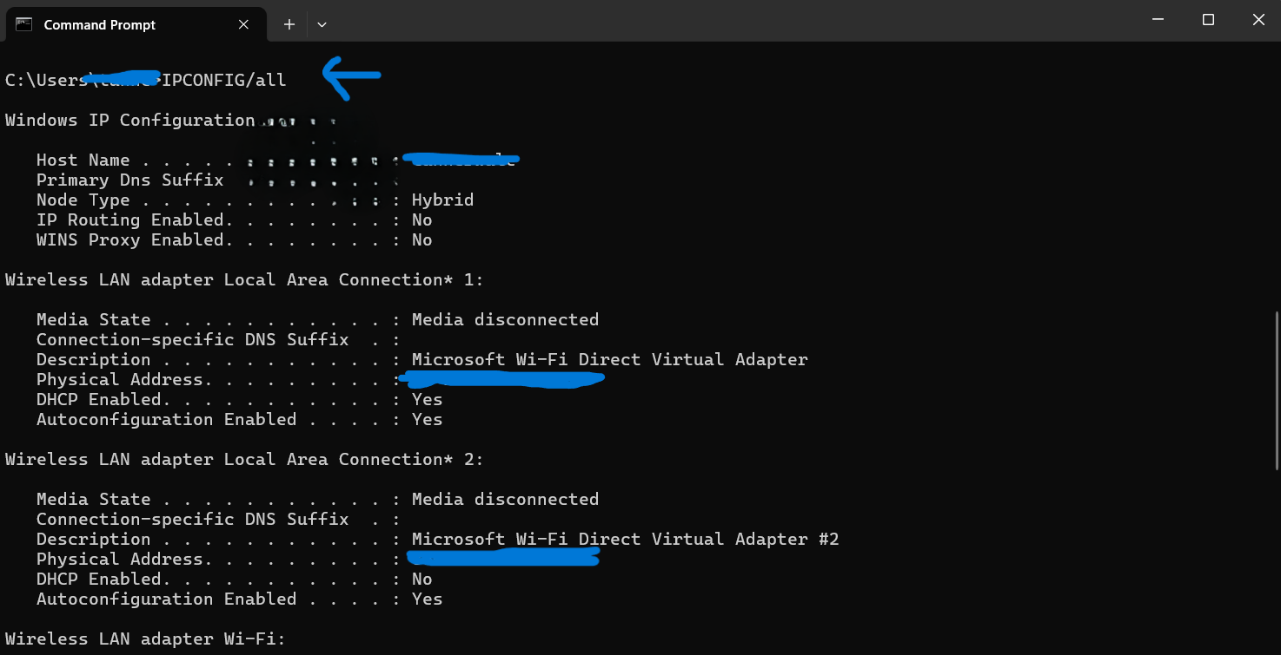

Alt text: Command Line Interface (CLI) tool after command IPCONFIG /all was used. Showing Host Name, DHCP enabled setting, and more.

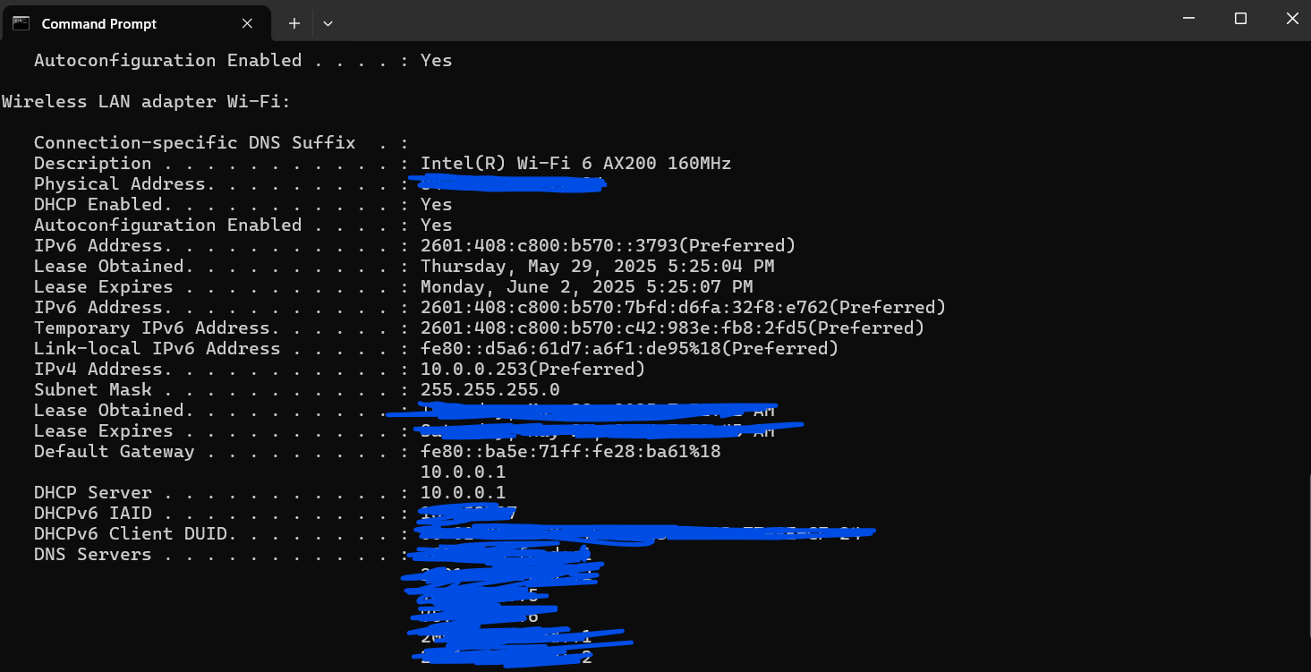

Alt text: More information after using IPCONFIG /all showing IP address, DNS server, and Default Gateway.

## **Software Packages**

Software packages function as a system management tool for utility software. This is because helping software applications on a device with installing, updating, or deleting processes. The process can be automatically done through automation to make it convenient for the user. Software packages utility software is also known as a security type because it can protect against malicious software packages. It does this by checking digital signatures of the software packages. You can also roll back versions of the software packages. Which can help with security by allocating security in spots where an organization sees a vulnerability from a previous update. If the new update has a zero-day attack or an unknown attack. Rolling the update back can also help to mitigate that concern to security. Examples of software packages include Winget, Homebrew, and Advanced Packaging Tool (APT).

Also below is a screenshot of using MSIX on windows from the Microsoft Store. MSIX can check for updated drivers for operating systems before running into problems loading applications with outdated drivers. Also, MSIX does a great job at restarting your device after downloading a software package. This is useful so that there is no chance of unnecessary data collection. MSIX will disable Windows Update, so no data will be collected. While WSIX packages the application chosen by the preferences of the user. This helps secure updates, installation, and uninstallation of software applications.

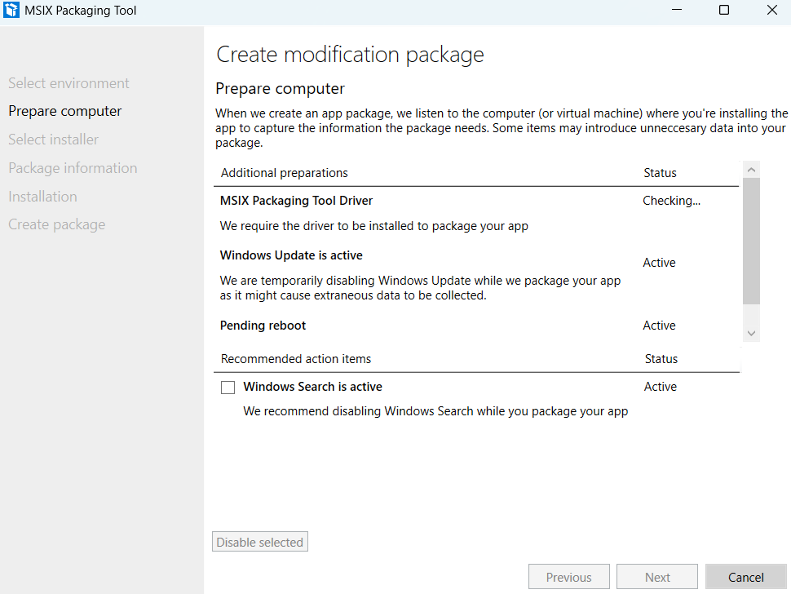

Alt text: MSIX packaging tool being used to check for updates on software packages, computer updates, and driver updates.

## **Why It's Crucial for System Optimization**

The reason utility software is crucial for system optimization. Is that it provides better performance by utilizing efficient applications over less efficient applications. By doing this the device will have less to keep track of. When the user boots up their device to when they log off their device.

Optimization of the CPU, RAM, and disk utilization of read and write operations will occur less upon boot up. Leaving more room for processing; leading to a longer life cycle of the device. Trojan horses, malware, and viruses can cause system crashes, faulty hardware, and issues with software. The utility software will stop the user from downloading malicious files. Which in turn will prevent potential hardware or software issues.

By using utility software for system optimization, you can save costs of replacing hardware or software issues. Find the root of the issue. Which will be diagnosed by the debugging software, and given recommended steps to fix the issue. Not only is this cost-effective, but this can lead to faster recovery time.

Manage files and folders as well as manage privileged access to them. This is a good organization tool for file management as you’ve read. Access control to your organizational or personal files will have to be given, in order for full access. This is a security policy to have access permissions in place. Organizations often use this to make sure they can use the security design principle of least privilege. That orchestrates only giving employees the access they need to do their daily tasks. This is a security precaution, so that unauthorized access to sensitive data is not breached. Until being authorized for access, by their access control privileges.

By having utility software, you can use system optimization to better keep track of changes, automated reports of potential attacks and automatically defend against websites and email phishing attacks. Also, attacks like malware in an email attachment. The utility software does not allow for sending or receiving known malicious emails that it can spot.

To conclude, utility software helps in organization’s devices and personal devices. Data management, security, reporting issues, access control privileges, software updates, troubleshooting device connection to the network, and configuration of the devices. There is still more utility software can do than this. You can be better informed to make changes to devices, smart changes that better suit your devices life cycle. By using these types and functions your device's life cycle will benefit immensely, prolonging the life of the device.

## **References**

1. <https://insidermarketresearch.com/pc-systems-utility-software-enhancing-performance/>
2. <https://www.indeed.com/career-advice/career-development/utility-software>
3. <https://www.savemyexams.com/gcse/computer-science/edexcel/20/revision-notes/3-computers/software/the-purpose-and-functionality-of-utility-software/>
4. <https://cards.algoreducation.com/en/content/CzdKpD84/utility-software-importance>
5. <https://www.lenovo.com/us/en/glossary/utility-software/>
6. <https://artoftesting.com/utility-softwares>
7. <https://timespro.com/blog/what-is-utility-software-and-why-is-it-important-for-computers>
8. <https://blog.emb.global/learn-about-utility-software/>
9. <https://www.lenovo.com/au/en/glossary/utility-software/>
10. <https://pegasun.com/system-utilities>
11. <https://logit.io/blog/post/system-monitoring-tools/>
12. <https://www.webroot.com/us/en/home/products/pc-optimizer>
13. <https://www.lenovo.com/us/en/glossary/utility-software/>
14. <https://blog.emb.global/learn-about-utility-software/>
15. <https://www.indeed.com/career-advice/career-development/utility-software>
16. <https://insidermarketresearch.com/pc-systems-utility-software-enhancing-performance/>
17. <https://cards.algoreducation.com/en/content/CzdKpD84/utility-software-importance>
18. <https://www.vaia.com/en-us/explanations/computer-science/computer-systems/utility-software/>